

**DAYANANDA SAGAR UNIVERSITY**

**DEPT. OF COMPUTER SCIENCE AND ENGINEERING**

**SOFTWARE REQUIREMENT SPECIFICATION**

**TOPIC: RAILWAY MANAGEMENT SYSTEM**

**5TH SEMESTER -3RD YEAR**

**DBMS PROJECT**

**TEAM MEMBERS:**

***MUSKAAN GOEL(TEAM LEADER)***

***LYSETTI LAKSHMI POOJITHA***

***MEGHANA SHREE M***

***MUSKAAN SINHA***

**GUIDE: PROF. BHARGAVI MOKASHI (DEPT. OF COMPUTER SCIENCE AND ENGINEERING)**

**TABLE OF CONTENTS ACKNOWLEDGMENTS**

Abstract...................................................................................................................

Introduction...........................................................................................................

Project Description..............................................................................................

List of Entities & Attributes...............................................................................

ER Diagram (Conceptual Model) ....................................................................

Normalization Schema Diagram.....................................................................

Final List of Relations ......................................................................................

Create & Insert SQL Queries.............................................................................

SQL Queries related to Report Generation...................................................

Conclusion .........................................................................................................

**ABSTRACT:**

The Railway Reservation System facilitates the passengers to enquire about the trains available on the basis of source and destination, Booking and Cancellation of tickets, enquire about the status of the booked ticket, etc. The aim of case study is to design and develop a database maintaining the records of different trains, train status, and passengers.

This project contains Introduction to the Railways reservation system .It is the computerized system of reserving the seats of train seats in advanced. It is mainly used for long route. On-line reservation has made the process for the reservation of seats very much easier than ever before.

In our country India, there are number of counters for the reservation of the seats and one can easily make reservations and get tickets. Then this project contains entity relationship model diagram based on railway reservation system and introduction to relation model .There is also design of the database of the railway reservation system based on relation model. Example of some SQL queries to retrieves data from rail management database.

**INTRODUCTION:**

Database is an organized collection of data. The data is typically organized to model aspects of reality in a way that supports processes requiring information. A DBMS makes it possible for end users to create, read, update and delete data in a database. The DBMS essentially serves as an interface between the database and end users or application programs, ensuring that data is consistently organized and remains easily accessible. The DBMS manages three important things: the data, the database engine that allows data to be accessed, locked and modified and the database schema, which defines the database’s logical structure. These three foundational elements help provide concurrency, security, data integrity and uniform administration procedures. The DBMS can offer both logical and physical data independence. That means it can protect users and applications from needing to know where data is stored or having to be concerned about changes to the physical structure of data.

The main purpose of maintaining database for Railway Reservation System is to reduce the manual errors involved in the booking and cancellation of tickets and make it convenient for the customers and providers to maintain the data about their customers and also about the seats available at them.Due to automation many loopholes that exist in the manual maintenance of the records can be removed. The speed of obtaining and processing the data will be fast. For future expansion the proposed system can be web enabled so that clients can make various enquiries about trains between stations. Due to this, sometimes a lot of problems occur and they are facing many disputes with customers. To solve the above problem, we design a database which includes customer details, availability of seats in trains, no of trains and their details.

**PROJECT DESCRIPTION:**

This project is about creating the database about Railway Reservation System. The railway reservation system facilitates the passengers to enquire about the trains available on the basis of source and destination, booking and cancellation of tickets, enquire about the status of the booked ticket, etc. The aim of case study is to design and develop a database maintaining the records of different trains, train status, and passengers. The record of train includes its number, name, source, destination, and days on which it is available, whereas record of train status includes dates for which tickets can be booked, total number of seats available, and number of seats already booked.

Passengers can book their tickets for the train in which seats are available. For this, passenger has to provide the desired train number and the date for which ticket is to be booked. Before booking a ticket for a passenger, the validity of train number and booking date is checked. Once the train number and booking date are validated, it is checked whether the seat is available. If yes, the ticket is booked with confirm status and corresponding ticket ID is generated which is stored along with other details of the passenger. The ticket once booked can be cancelled at any time. For this, the passenger has to provide the ticket ID (the unique key). The ticket ID is searched and the corresponding record is deleted. With this, the first ticket with waiting status also gets confirmed.

List of Assumption Since the reservation system is very large in reality, it is not feasible to develop the case study to that extent and prepare documentation at that level. Therefore, a small sample case study has been created to demonstrate.the working of the reservation system.

To implement this sample case study, some assumptions have been made, which are as follows:

1. The number of trains has been restricted to 5.

2. The booking is open only for the next seven days from the current date.

3. Only two categories of tickets can be booked, namely, AC and General.

4. The total number of tickets that can be booked in each category (AC and General) is 10.

5. The total number of tickets that can be given the status of waiting is 2.

6. The in‐ between stoppage stations and their bookings are not considered.

List of trains has to be maintained. Detailed Passenger information is to be maintained In the booking procedure, the train number, train date, and category are read from the passenger. On the basis of the values provided by the passenger, a corresponding record is retrieved from the Train_Status. If the desired category is AC, then the total number of AC seats and number of booked AC seats are compared in order to find whether tickets can be booked or not. Similarly, it can be checked for the general category. If a ticket can be booked, then passenger details are read and stored in the Passenger table. In the cancellation procedure, ticket ID is read from the passenger and corresponding record is searched in the Passenger. If the record exists, it is deleted. After deleting the record (if it is confirmed), the first record with waiting status for the same train and same category are searched from the Passenger table and its status is changed to confirm.

**LIST OF ENTITIES & ATTRIBUTES:**

|  |  |
| --- | --- |
| **ENTITIES** | **ATTRIBUTES** |
| User | User_id  Password  First_name  Last_name  Gender  Age  Email  Aadhar_no  Mobile_no  City  State  Pincode  Security_ques  Security_ans |
| Passenger | Passenger_id  Name  Gender  Age  Pnr_no  Seat_no  Booked_by  Reservation_status |

|  |  |
| --- | --- |
| Train | Train_no  Train_name  Source  Destination  Arrival_time  Departure_time  Avalibility_of_seats  Train_no  A_seats1  A_seats2  A_seats3  B_seats1  B_seats2  B_seats3  W_Seats1  W_seats2  W_seats3 |
| Station | Station_Name  Station_No  Train_no  Arrival_time  Hault |
| Ticket | Ticket_id  User_id  Train_no  Booked_user  Status  No_of_passengers |

**ER DIAGRAM (CONCEPTUAL MODEL):**

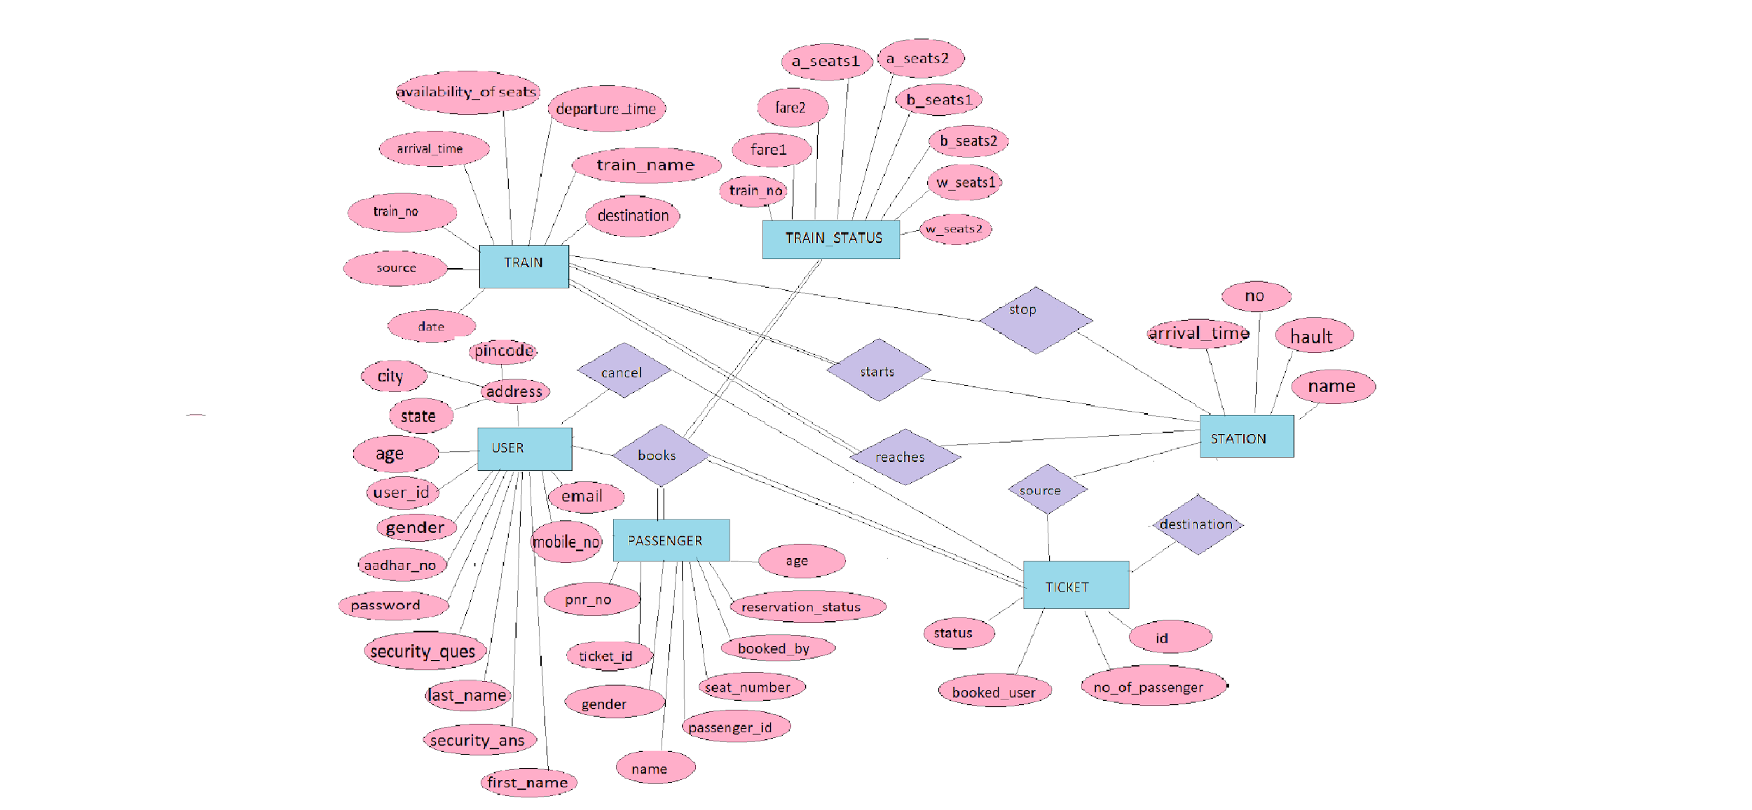

**Normalization Schema Diagram:**

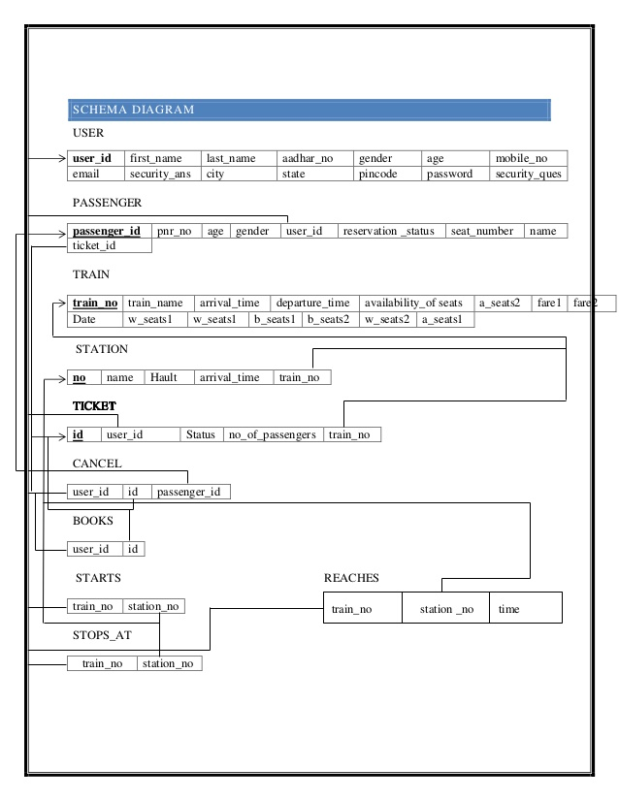

**FINAL LIST OF RELATIONSHIPS:**

1. books -Ternary relationship between USER,TRAIN,PASSENGER and TICKET.
2. starts –Between TRAIN and STATION
3. reaches –Between TRAIN and STATION
4. cancel –Between USER and TICKET
5. stops_at –Between TRAIN and STATION

**CREATE & INSERT SQL QUERIES CREATE COMMANDS:**

**CREATE QUERIES:**

CREATE TABLE USER(USER_ID INT PRIMARY KEY,_PASSWORD VARCHAR(50),SECURITY_QUESTION VARCHAR(50),SECURITY_ANSWER VARCHAR(50));

CREATE TABLE TRAIN(TRAIN_NO INT PRIMARY KEY,TRAIN_NAME VARCHAR(50),ARRIVA_TIME TIME,DEPARTTURE_TIME TIME,AVAILABILITY_OF_SEATS CHAR,DATE DATE);

CREATE TABLE STATION(STATION_NO INT,STATION_NAME VARCHAR(50),HAULT INT,ARRIVAL_TIME TIME,TRAIN_NO INT,PRIMARY KEY(STATION_NO,TRAIN_NO),FOREIGN KEY(TRAIN_NO) REFERENCES TRAIN(TRAIN_NO));

CREATE TABLE TRAIN_STATUS(TRAIN_NO INT PRIMARY KEY,B_SEATS1 INT,B_SEATS2 INT,A_SEATS1 INT,A_SEATS2 INT,W_SEATS1 INT,W_SEATS2 INT,FARE1 FLOAT,FARE2 FLOAT);

CREATE TABLE TICKET(TICKET_ID INT PRIMARY KEY,USER_ID INT,STATUS CHAR,NO_OF_PASSENGERS INT,TRAIN_NO INT,FOREIGN KEY(USER_ID) REFERENCES USER(USER_ID),FOREIGN KEY(TRAIN_NO) REFERENCES TRAIN(TRAIN_NO));

CREATE TABLE PASSENGER(PASSENGER_ID INT PRIMARY KEY,PNR_NO INT,AGE INT,GENDER CHAR,USER_ID INT,RESERVATION_STATUS CHAR,SEAT_NO VARCHAR(50),NAME VARCHAR(50),TICKET_ID INT, FOREIGN KEY(USER_ID) REFERENCES USER(USER_ID),FOREIGN KEY(TICKET_ID) REFERENCES TICKET(TICKET_ID));

CREATE TABLE STARTS(TRAIN_NO INT PRIMARY KEY,STATION_NO INT,FOREIGN KEY(TRAIN_NO) REFERENCES TRAIN(TRAIN_NO),FOREIGN KEY(STATION_NO) REFERENCES STATION(STATION_NO));

CREATE TABLE STOPS(TRAIN_NO INT,STATION_NO INT,FOREIGN KEY(TRAIN_NO) REFERENCES TRAIN(TRAIN_NO),FOREIGN KEY(STATION_NO) REFERENCES STATION(STATION_NO));

CREATE TABLE REACHES(TRAIN_NO INT,STATION_NO INT,TIME TIME,FOREIGN KEY(TRAIN_NO) REFERENCES TRAIN(TRAIN_NO),FOREIGN KEY(STATION_NO) REFERENCES STATION (STATION_NO));

CREATE TABLE CANCEL(USER_ID INT,TICKET_ID INT,PASSENGER_ID INT,FOREIGN KEY(TICKET_ID) REFERENCES TICKET(TICKET_ID),FOREIGN KEY(PASSENGER_ID) REFERENCES PASSENGER(PASSENGER_ID),FOREIGN KEY(USER_ID) REFERENCES USER(USER_ID));

**INSERT QUERIES:**

INSERT INTO USER VALUES(150,"HELLO","AGE",20),

(165,"HELLOO","AGE",20),(177,"HELLOOO","AGE",20),(178,"HELLOOOO","AGE",20);

INSERT INTO TRAIN VALUES(1001,"RAJDHANI",11,1,"P",20201011),

(1002,"INDIAN_RAILWAYS",12,2,"M",20201011),(1003,"KARNATAKA_EXPRESS",13,3,"G",20201011),(1004,"MUMBAI_EXPRESS",14,4,"S",20201011);

INSERT INTO STATIONVALUES(100,"RAJASTHAN",10,112030,1001),

(101,"DELHI",11,112131,1002),(102,"BANGALORE",12,112032,1003),

(103,"MUMBAI",13,112132,1004);

INSERT INTO TRAIN_STATUS VALUES(1001,90,91,80,81,70,71,7000,6000),

(1002,20,21,30,31,40,41,9000,8000),(1003,10,11,20,21,60,68,7500,5400),(1004,33,34,56,57,87,89,8700,4567);

INSERT INTO TICKET VALUES(9880,150,"A",5,1001),(9881,165,"N",4,1002),

(9882,177,"A",3,1003),(9883,178,"N",2,1004);

INSERT INTO PASSENGER VALUES(1500,123,20,”F”,150,”A”,21,"POOJITHA",9880) ,(1650,234,20,"F",165,"A",22,"MEGHANA",9881),(1770,345,20,"F",177,"A",23,"MUSKAANG",9882),(1780,456,20,"F",178,"A",24,"MUSKAANS",9883);

INSERT INTO STARTS VALUES(1001,100),(1002,101),(1003,102),(1004,103);

INSERT INTO STOPS VALUES(1004,100),(1003,101),(1002,102),(1001,103);

INSERT INTO REACHES VALUES(1001,103,112233),(1002,102,122334),

(1003,101,132435),(1004,100,142536);

INSERT INTO CANCEL VALUES(150,9880,1500);

**SQL QUERIES RELATED TO REPORT GENERATION**

1. **print user id and name of all those user who booked ticket for** KARNATAKA_EXPRESS
2. **print details of passengers travelling under ticket no 9882**

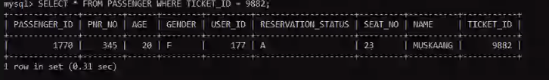

**3.display all those train no's which reach station no**

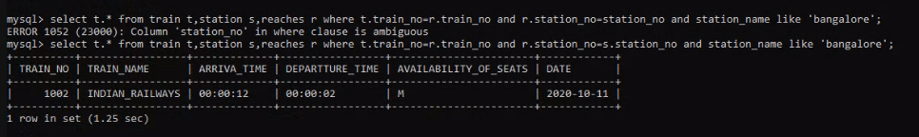

**4. display time at which train no----- reaches station no ------**

**5.display details of all those users who canceled tickets for train no--**

**6. display the train no with increasing order of the fares of class 1**

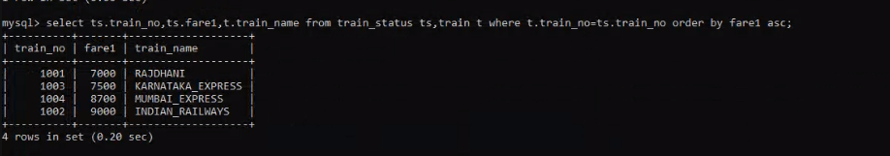

**7.display passenger details for train pinakini.**

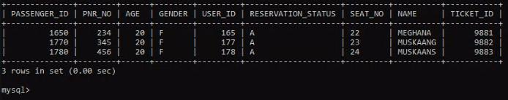

**8 display immediate train from tirupathi to Vijayawada**

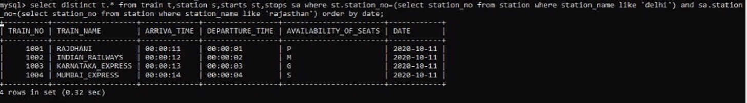

**9.display the train no which haults for more time in station no---------**

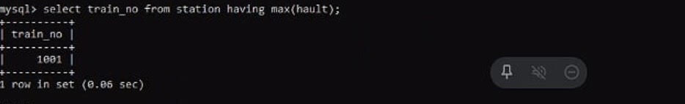

**10. display details of all those passengers whose status is confirmed for train no---- -------**

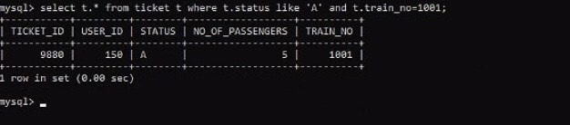

**select p.* from passenger p,train t,ticket tc where tc.train_no=t.train_no and tc.ticket_id=p.ticket_id and t.train_name like "rajdhani";**

**select distinct t.* from train t,station s,starts st,stops sa where st.station_no=(select station_no from station where station_name like 'delhi') and sa.station_no=(select station_no from station where station_name like 'rajasthan') order by date;**

**select train_no from station having max(hault);**

**select t.* from ticket t where t.status like 'A' and t.train_no=1001;**

**CONCLUSION:**

In our project Railway reservation system we have stored all the information about the Trains scheduled and the users booking tickets and even status of trains, seats etc. This database is helpful for the applications which facilitate passengers to book the train tickets and check the details of trains and their status from their place itself. It avoids inconveniences of going to the railway station for each and every query they get. We had considered the most important requirements only, many more features and details can be added to our project inorder to obtain even more user friendly applications. These applications are already in progress and in future they can be upgraded and may become part of amazing technology.